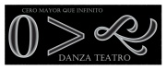
INTERNATIONAL DANCE COUNCIL (CID-UNESCO)
50TH WORLD CONGRESS ON DANCE RESEARCH
Mr. Prof. Félix Castellón Huerta

SITUATION OF CONTEMPORARY DANCE IN MEXICO CITY

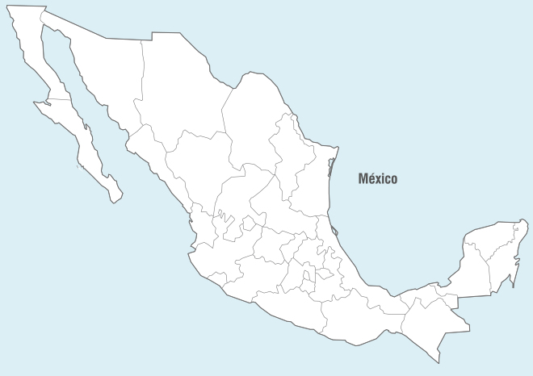

Date of realization: May 2017

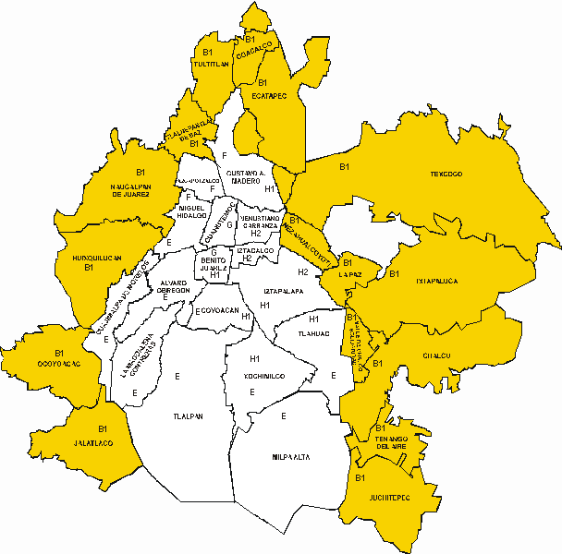
Just 1, 175, 075 inhabitants,
about 12% of the population of Mexico City
8 918 653 Inhabitants in Mexico City
5, 067, 517  Human Beings
7, 286, 715 Human Beings, about the 3rd part of Mexico City’s population
2, 219, 198 Human Beings
About 22.4 million people in the Megalopolis!!

DISTRIBUTION OF THE POPULATION IN MEXICO CITY
According to data from the National Institute of Geography and Statistics, in the 2015 population count, in the metropolitan area of Mexico City (the megalopolis) approximately 22.4 million people live, and in the 5 districts of the northern area we inhabit 2, 888, 893 People: a third of the total of the inhabitants of the city, in addition, counting to the 5, 067, 517 people who live in the municipalities of the State of Mexico with which the city limits (Naucalpan, Tlalnepantla, Tultitlán, Coacalco, Ecatepec And Nezahualcoyotl), we see that in the north of the Metropolitan Area of Mexico City we coexist daily about 7, 956, 410 people.
The population density of Mexico City is 5 967 inhab / km2, being the tenth Megalopolis in the world more densely populated and with an acceptable socioeconomic level to lead a half-decent life. The northern part of the City is, therefore, one of the most densely populated in the world.
In this context, if only a minimum percentage of the inhabitants of this area of the City (1% = 79,564) were consumers of Contemporary Dance, we would have a captive pubic, and therefore, constant and safe work.
For purposes of a socially responsible analysis, we see that the 'cultural activity' in Mexico City (teaching-learning, practice, diffusion, promotion, presentation, contemplation, etc.) concentrates mainly in the area conformed in a small perimeter In the Center of the City , and in other small 'cultural corridors', making the peripheries excluded de facto from this activity.
Perhaps this exclusion, which in many cases is explicit, is due to a perception- fairly ominously embedded in the minds of the citizens - that the periphery (north, east and west) of the city "are proletarian, middle-class, skid row areas", that the south end "is still very rural", and that in all cases the people who live there "their educational level is low or medium and their forms of entertainment are those that are mostly obtained through the influence of the mass media, private television"... unfortunately this type of Perceptions are real and, even worse, come to be expressed by the same colleagues of the Dance who are inhabitants of these same areas!
DISTRIBUTION OF THEATERS, FORUMS AND OTHER PLACES FOR THE OFFER OF DANCE SHOWS
How, then, could we capture a part of the potential of this unsuspecting public, who makes up about 8% of the country's population!
Yes, designing and carrying out activities such as Workshops, Courses, Exhibitions, Seminars, Functions, Formal Seasons, Cycles, etc., to which communities, knowing that there is this type of artistic expression near where they live, would be interested and they would come to know and eventually practice it.

But where could they do it?
In Mexico City (which is a reflection of what happens throughout the country), the appreciation and organization of the theaters is also carried out in a context of 'class struggle', so there is a kind of unofficial categorization of The importance of the artistic infrastructure. Thus we have, in order of rank, from the lowest: the Community Centers, followed by the Houses of Culture and the Independent Forums, then the Forums and Cultural Centers Delegation (Municipal) and Theaters and Private Forums Granted or Sponsored, The highest category are theaters and Forums administered by the City government, Federal Secretaries and Trade Unions as well as those belonging to National Multimedia Companies; Finally, those of greater importance are theaters, cultural centers and forums of national relevance that run the Educational and Governmental Institutions... of these spaces there are very few.
Important: no one considers outdoor spaces in this categorization.
According to this classification, we have the infrastructure in which contemporary dance can be housed and developed (according to the document without update date http://www.aldf.gob.mx/archivo-6ce59b2fd6832581fd93f14b25cdf26e.pdf, issued by the Legislative Assembly of Mexico City), there are 182 venues, among them the National Center of the Arts that houses three of the five spaces specialized in Dance of the City, namely: Raúl Flores Canelo Theater, Plaza de la Danza and Experimental Forum 'Black Box'; The Centro Cultural Universitario where the Sala Miguel Covarrubias is located - the same architect, besides giving his name, specially designed for the realization and enjoyment of the dance; Both Cultural Centers are in the Center-South area; And the Cultural Center of the Forest (zone Center West) where is the Theater of the Dance. That is, there are only 5 forums specialized in dance and all are located in the Center-South area of ​​the City.
The rest of the enclosures, which would add around 250, not counting those in the municipalities of the metropolitan area or open spaces such as Squares and Gardens, are scattered throughout the territory, and at least two thirds of them, approximately 67%, are suitable for activities related to contemporary dance.

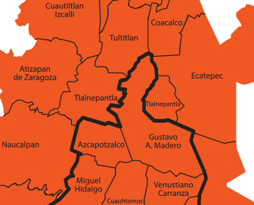
*Enclosures suitable for the practice of Contemporary Dance in the North area of Mexico City

2
1
2
4
1
3
1
1
2
3
5
4
6
7
1
1
2
1
3
4
2
5
1
2

Particularly in the 'Arco Norte' of Mexico City, specialized spaces for dance are nonexistent. And the spaces for the practice, study and diffusion of the Contemporary Dance are extremely scarce. However, there are spaces that are not specialized but that fit well; this makes us think that the development of the discipline in this, and other 'peripheral' areas of the City, is feasible.
* The above image shows a brief 'mapping' of the location of spaces (theaters, educational institutions and cultural centers) suitable for the practice of Contemporary Dance. There are registered 24 theaters and closed forums belonging to different governmental and educational institutions.
It is symptomatic that in the most populated district of this area there are 23 Centers for the Promotion and Development of Artistic Culture (between Community Centers, Houses of Culture and Cultural Centers), but that have no relevance to the community of the district nor to the population of the City, since very few people know it and therefore do not have access to what is done there....
This occurs in all areas of the City. Making a projection we see that, on average, in each one of the 16 istricts that construct the territory of the City, there would be at least 6 Centers where contemporary dance could be developed.
When planning and designing the urban area north of the city, it was thought that there would be centers of leisure and culture that would complement community development - and perhaps continue to do so - but it has not been as relevant as it should be.
This problem is widespread, and although in the Historic Center (which is in fact located in the Center-North area) is a large number of important enclosures of local, national and international relevance and they have great potential for the development of contemporary dance, are scarcely used for this. This happens even in the Center-West area, where purchasing power is high, and where one of the most important Cultural Centers in the country is located: the public does not go to contemporary dance shows, although there is the 'Theater of the Dance'.
Neither the public and private educational centers in these areas, are considered as spaces where academic, creative and promotional activities can be carried out on a constant basis, they are not taken into account as natural centers for generating new audiences and as 'seedlings' of new artists.
Actually, if considered as alternative spaces, including Squares and Gardens, we could be made seasons and presentations, constant or permanent. In this way, a precedent could be set, so that the creators of other disciplines also hold meetings or festivals that give them a boost and projection into areas of the City that are poorly attended, thus promoting the creation of an 'Artistic Culture' and its system, first between the community of each delegation and then in a Circuit that includes the inhabitants of the 'periphery' of the City in general, as well as with the municipalities of the State of Mexico, this without disassociating the well established system that is In the Center-South.
It can be asserted, then, that there are enough spaces and with very good options for the development of discipline, and, above all, that there is a public eager to consume new and different artistic manifestations, and that can be generated improvements in the field of Cultural Policies, Tourism, Services, Social Development and Economy, among others. Perhaps they are very broad and still incipient perspectives, but I am convinced that the permanent practice of Contemporary Dance in the 'peripheral zones' can be a reference of the Artistic Culture of Mexico City.
DISTRIBUTION OF EDUCATIONAL SERVICES OFFER
In relation to the centers and educational spaces for contemporary dance, it is also concentrated in the schools of the National Institute of Fine Arts, such as the National Schools of Contemporary Dance and the National School "Nelly and Gloria Campobello", Mexican Academy of Dance and Center Of Choreographic Research, as well as in the Centers of Artistic Education (baccalaureate level) and of Artistic Initiation; The City government has an educational system in dance that concentrates in the Ollin Yoliztli Cultural Center and School of Initiation to the Dance; Neither the National University nor the National Polytechnic Institute consider in its mission the creation of the Faculty or a National Dance School.
In fact, there are many, althoug not enough, options for teaching and learning contemporary dance in Mexico City, among which there is a diversity of centers, academies and schools in which discipline is taught at all levels, genres and Styles: from the most basic - for those who have never danced -, to the highest, which even teach international teachers for professionals of the Dance.
The training centers, in fact, are mostly private and independent, have to perform self-management or compete for government financial support, so that conditions are constantly precarious and costs for courses, workshops, degrees, diplomas, etc., usually Be high and inaccessible to the majority of interested students; This means that only people with higher purchasing power, who generally live in the areas where the national cultural centers, which concentrate the infrastructure and educational services, are those who have the best possibilities of accessing them.
This does not mean that the rest of the population of the City does not have the slightest chance, although there are many people who accede to it, but they have to make a great sacrifice because they have to travel a long time in public transport or look for lodging nearby, among other vicissitudes, which entails, in fact, a greater expenditure in all the senses.
Although there are, for example, at least eight cultural centers in the northern part of the City where formal Dance Plans and Programs of Contemporary Dance can be implemented, there is no way that those who manage them can even consider this possibility, this due to the policy of the public administration of the City that is based on the development of the financial economy instead on human development....
A very viable option is to create more independent centers in which the costs are accessible and friendly, especially for young people, who are most eager to approach to contemporary dance.
DISTRIBUTION OF THE OFFER
With these data it is evident that a large number of this population is eager to have access to the goods that provide a better quality of life. I can then, with responsibility, infer that it is a claim that implies social justice, and that such improvement of the state of life can be obtained through the benefits provided by Artistic Culture. In this way, artistic activity (practice, diffusion, promotion, etc., in this case of contemporary dance) must be a daily fact, accessible to all people.

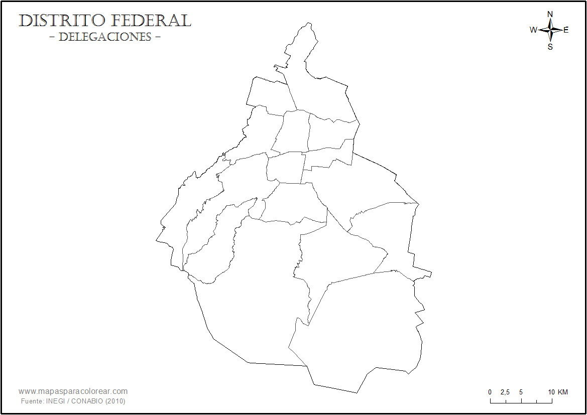

There are undoubtedly the strong lags in these and other areas of the City related to almost no access to all artistic manifestations, which I interpret precisely as a consequence of a vicious circle generated, to a large extent, by the same workers of different artistic disciplines, This happens, for example, when they consider that having a presence in these sites is not a priority, it is not part of their 'development prospects
And, as you can see, these spaces are concentrated mainly in two central areas of the City, areas where people with medium-high purchasing power live. In peripheral areas, the social level is medium or medium-low, and in order to reach places where services are concentrated, at least one hour of travel is needed, and costs and places are not fully accessible.
This is a great problem that has not allowed the contemporary dance to develop according to its potential, thinking about the quantity and quality of population of the City of Mexico and its artistic infrastructure...
COMPANIES AND GROUPS OF CONTEMPORARY DANCE EXISTING IN MEXICO CITY
In the Catalog of National Companies of the National Coordination of Dance, updated to 2014, are registered 65 Companies and 15 Soloists, all professionals.
One fact is that, at national level, there are registered more groups of Contemporary Dance than Folklore, Spanish, Urban, Salon, Traditional and others... and they have not yet registered all.
Thinking about the above, there is a deficit of at least 65% in the counting of companies in Mexico City, which means at least 30 professional companies more... Do not take into account the semi-professionals, nor the amateur, and the students.
As for Professional Soloists, there is a very small record, in fact the number of professional soloists of contemporary dance who live in Mexico City, making a calculation by intuition, it could be said that it is at least 6 times greater, that is, there are about 90 contemporary dance professionals who perform their work individually, and who are not registered.
Taking the data from the section in which I make a consideration of the appropriate spaces for the discipline, it can be deduced that, in each of these venues there is a contemporary dance group or company, in fact, it is quite possible that the quantity Of companies, groups and professionals of the discipline is greater than what is officially recorded.
I emphasize the importance of considering groups and companies newly formed by graduates of schools and academies, the companies created by the same students or representative groups of institutions, either amateurs who do not have a 'formal' or 'official' education and training, and the semi-professionals who still do not develop a solid academic-administrative and creative structure. If we take into account all these creators, the number of Companies, Groups and Professionals could even double and count to about 200 groups and some soloists.
This last fact, as I said and I assume, is an inference that I make intuitively. However, it is not very far from reality.
Why, then, contemporary dance is still so unknown and little practiced in Mexico City?
THE GREAT PUBLIC DEMAND
The heavy lags of the inhabitants of Mexico City related to the low accessibility to all artistic manifestations, I interpret it as a consequence of a problematic generated to a great extent by the same art workers: a great majority considers that the presence in the remote or marginalized areas is not a priority or that is not part of their "artistic and professional development prospects" (sic), because "there no one sees Contemporary Dance" (super-sic)... Of course they do not see it, because the people who live there do not even know what contemporary dance is!
And how could they know, if the artists do not want to go there? ... ... ... A pernicious circle that only causes more lag and, consequently, loss of values in all senses.
One of the main reasons why more meetings, festivals, cycles, season in these areas of the City should be held is for the recovery of the values of a population considered, with no reason (though in many respects right) of To be a 'slum-dweller', tend to crime, with low self-esteem, corrupt, short of understanding ... ergo: that "they could not understand the complexity of an abstract work in a language as exquisite as contemporary dance"...
During the realization of different events in the last 7 years, I have corroborated the urgent need of the inhabitants of the City to have new and different options of recreation, learning, expression, etc .; likewise, the desire to access what they perceive as an outsider is reflected, that is, "artistic performances of quality", which for many communities are understood almost as exclusive for the inhabitants of the Center-South of the City, and that for those who live in peripheral or remote areas of the Center, are unavailable... this is a claim that has become historic.
We must also consider that, although the ignorance of the discipline by this population is widespread, the public is NOT STUPID, and that it is perfectly possible (besides being a Human Right enshrined in our Political Constitution) that they approach and become spectators, both as consumers and creators of 'good quality art', so that not only are they offered services or products such as performances, workshops, exhibitions, etc., but that appropriate policies and mechanisms are created , so that all people who have the interest can access the different artistic manifestations of the dance in a daily way and can contribute to the cultural growth of their community. We have seen with great pleasure that, especially where these artistic manifestations are almost non-existent, people are particularly receptive, grateful and purposeful.
That is why the insistence that ALL involved in Contemporary Dance should be conscious, congruent and forceful when presenting proposals with the best quality possible, that meet the expectations of the population by observing their needs for cultural consumption, integrating at all times the Inhabitants of these communities.
ANALYSIS OF SOME CONSUMPTION HABITS AND THE PERCEPTION OF CONTEMPORARY DANCE BY THE INHABITANTS OF MEXICO CITY
It is fair to say that there is a strong interest among the population of the City to attend Contemporary Dance shows. The attendance, although varies depending on the capacity of each room and the area where it is located, is on average 50 attendees per function. In reality, it is very little, if we take into account the population data that I present at the beginning of this writing, and the public-consumer potential, especially in areas outside the city center; to increase the number of attendees would be very good to be constant in the presence in these areas of the City, so the influx of consumers could increase.
Something very encouraging is that the attending public is heterogeneous: in a slightly higher proportion of women, the average age ranges from 10 to 65 (although there have been smaller and larger attendees); the average educational level is baccalaureate; although about 20% of attendees have undergraduate and graduate levels... this audience is of special interest since it is a young adult population (between 25 and 54 years old) that has or can develop - by its educational level- a strong liking for discipline or encourage their children to practice it, in addition and because their purchasing power is regular, can be a public that does pay the fair cost for attending a performance.
The Mexican consumers of performing arts attend to a greater extent to Music shows, leaving in second place the Theater and to the end the Dance with 25% of attendees of the total surveyed. Those who attend Contemporary Dance, 31% (of that universe of 25%) say they know little or nothing, although 43% say "to know" that it is "a Body Expression", which is "Culture or Art".
Most respondents say they attend Stage Shows at least once every 3 or 6 months... from this, it is inferred that the average attendance to Contemporary Dance is much lower, given that -according to the National Survey of Habits , Cultural Practices and Consumption Conaculta 2010-, if in general to the Dance, on average, attends 25% of the public 'incautious', to Contemporary dance assists between 7% or 11% of that 25%, ie: 100 People who attend performances of scenic disciplines in Mexico, only 25 consume Dance, and of those 25 only 3 attend Contemporary Dance... and of those 3 only 1 does it outside the Downtown area. A worrying fact for those who dedicate ourselves to this beautiful discipline.
It is encouraging that more than 80% of attendees, although they do not have specific or specialized knowledge of the discipline, expressed their liking for it, whether it is performed by groups or individuals recognized in the national 'professional' field or by lay young people.
Some expressions of the spectators
Before the question "What does it take for a contemporary dance show to be completely pleasing to you?" They point out, first and by way of a claim, that it is necessary to broadcast it. This makes evident the urgent need to involve all sectors (governmental and private) interested in the area, so that the promotion and dissemination are effective.
To the question "What do you suggest to improve dance proposals?", the first thing they perceive is "The technique of dancers": a significant thing taking into account that their knowledge about dance techniques is almost nil. In my opinion they refer, in addition - and even more significant - to "The clarity of the message": this answer lets us know that although they express a taste for what they see and "feel the dance" (sic), they do not really understand what they are seeing. I emphasize explaining this term of Understanding: it is not that they manage to capture the message, argument, the 'thread' of the story or the concept, if not, rather, DO NOT FEEL THIS LANGUAGE LIKE SOMETHING NEAR TO THEIR EVERYDAY LIFE, AS SOMETHING OWN, and therefore, feel’s that the artists do not communicate with them, and not offer a language that is affordable, this causes their reaction to be rejection, and choose not to attend more shows of the discipline because they DO NOT UNDERSTAND it... maybe it is time to review the stage speeches and how we offer it (the language) to the public, since it is one of the great probable causes of why, according to the words of one administrator of a Theater said: "Contemporary Dance is not popular"(super-sic).
I am particularly concerned to report that at least one third of his comments refer to "The lack of communication between the artist and the public"; this I interpret, and in congruence with the previous argument, that there is no relation between what happens on the stage and the actual experience of the audience, that is, the artist on stage forgets about his audience and does not communicate with him, at least not efficiently: "it seems that they dance for themselves" (vox populli dix it).

It is, however, refreshing and motivating to know that 66% of attendees, after seeing a show of the discipline, would be interested in attending more frequently performances such as enrolling in courses and workshops permanent or itinerant, and even formally participate in some larger grouping or project.
Finally, to the express question of "Who should organize, encourage, produce, sponsor this kind of events?", the constant and majority responses and comments was that "It is a duty and obligation of governments", in lesser proportion, but no less relevant, is that "It must be the private initiative, the sponsors", and lastly "The same artists" ...
Perhaps we should do a more thorough review of this heading, since we are acting exactly contrary to public perception.
PROPOSALS FOR THE DEVELOPMENT OF THE DISCIPLINE IN THE CITY OF MEXICO
- To meet constantly with those directly interested (Choreographers, Directors, Producers, Dancers, etc.) in an informal way, preferably, in the beginning, in order to really meet us, to know each other as people who coincide in an artistic sphere; Then formalize these encounters with cooperative dynamics.
- Generate documents with which to reach agreements of an Organizational, Administrative, and even Legal-Labor nature in which the needs and benefits of all involved are raised.
- Involve people and institutions (public and private) specific to the area and related fields, in the realization of these efforts, which would also benefit.
- To integrate Creators and Collaborators of the different disciplines inherent to the Dance (Promoters, Dressmakers, Illuminators, Graphic Designers, Photographers, etc.).
- Propose insistently and carry out, in a joint and organized way, Performances, Seasons, Cycles, Workshops, Courses, etc., to the managers of the scenic and cultural spaces in order to maintain a persistent presence in them, also generating sources of work and mobility of dance works, giving to the consumers the possibility of discerning between a wide variety of proposals.
CONCLUSIONS
I can only conclude that it is very important that we generate, collectively and cooperatively, a system for contemporary dance through which the Artists-Workers of the discipline can have a dignified development, the cause of our work, so that we can carry our messages in a clear and forceful way to that great public that is eager to obtain the benefits of the Artistic Culture.
The present writing is rather a provocation; I hope it will be well received by all and that soon we will be collaborating in the realization of intelligent and generous projects.
I greet you affectionately, desiring you to enjoy the greatest virtues of life.

