CID"International Dance Council / UNESCO Partner

50th Congress world research in dance - Athens from 5 to 9 July

- - - - - - - - - - - - - - - -

Pedagogic comments: Have you a body for every one of your activities?

To walk is to dance, but to dance is it to walk?".
Creating new pedagogy for teaching dance as a couple
Dance support “Argentine tango “

1) Professor
2) Definition of the word 'Dance'
3) Prologue
4) Reflection
5) Moving - action to walk:
6) Walking with the imbalance "innate primary"
6a. Progression through frontal movement (the body progresses to a point' A' to point 'B')
6b. Progress by lateral displacement (the body changes its line from point' A' to point 'B')
6c. Oscillation by front displacement = change of support (the body remains on its positioning)
7) Terms used for my teaching
8) Diagram of the functioning of the human body
9) The communication necessary to create the couple dancing
10) Transcript of communications applied to the Argentine tango
11) Components to create the couple dancing
12) Music: fundamental to 'dance'
13) TANGO ARGENTIN
14) The pedagogy applied to other dances - the move database
15) When you're a couple in front of you, what is your pedagogy?
- - - - - - - - - - - - - - - - - - - - - - - - - - - - - - - - - - - - - - - - - - - - - - - - - - - - - - - -
1) Teacher: Dances tell "show" are the common thread of his life. At the end of the 1980s, he met Mr Yves LAFON, dance master in Paris, and follows the curriculum of teacher in dance "standard and Latin" in four years.
- 1 January 1994, he opens its course at Dinard and Rennes (Brittany/France).
(The training is based on the movement of the legs (steps) to create choreographic drawings on the ground, the pelvis and the bust following; the projection of the center of gravity is always positioned between the two supports (feet)).
- 1 September 2002, he completely abandoned this philosophy and chose to teach from the performance initiated by nature:
o the pelvis deplacement to place our center of gravity in various points constituting a choreography in tango and other dances in couple or with two people (including standart and latin dances).
The pelvis and the bust forward, legs follow, are placed in the vertical center of gravity, and ensure balance.

2) Definition of the word 'Dance' : To move the body in rhythm. Action to execute a set of body movements, willingly and with rhythm, usually accompanied by music or a song (Larousse dictionary).

3) Prologue: 'Dance' is the generic name defining several families (variants or styles). This can imply a base of initial teaching...

Under the heading of "learning to dance as a couple," we learn the technique of one dance, then another, and so on. ... without imagining a possible relationship between these techniques!
Yet all couple dances belong to the same family. Dance is universal.
With the universal teaching that I propose, the family of "popular dances", and specifically "dances as a couple", using identical or comparable move and codes can therefore receive a basic teaching that gives the possibility to access and dance quickly, without other courses, all variants.

- Réflexion :
On our planet, for all that is "life" nature has created a logical functioning and adapted to its role (its existence).
Only a "person" has the additional option to change the primary operation in a "very short time" compared with the "long time" of the evolution of nature. Thus, if you use your body to perform a gesture or a series of gestures, these repetitive gestures will become familiar and easy. They will seem "natural" to you, but they are only repetitive, habits and non-evolutive.
It is better, it's easy to take these actions in harmony with the logical operation.
For each, our body is irreplaceable. Mister Jean Racine (the litigants, 1668) wrote: "who wants to travel far household his mount".
Conclusion respect the creation of nature. For all your activities, you will save time and well-being.

5) Our move action of walking:
During our first attempt, under the impulse of our reptilian memory, we tried logically to launch the top of our body to "go" towards our envy. Our reptilian memory immediately "printed" the danger of this action. . At the second try we advanced the pelvis forward to create this same action; The bust followed; One of our legs accompanied and assured our balance in the end this displacement (fall). We walked.
We all discovered this natural movement that we used in our first year.
Humans differentiate themselves from other species by their ability to modify "things" in "short" time. How many years after, for many reasons, most of us have first placed one leg forward, then" pulled "our body? »...
There are two ways to move :
- Proposal 1 / natural law : When you move your body, your legs follow.

Our pelvis by moving leads with a slight delay the bust from point 'X' to point 'Y '. At the end of the projection of the body, secure fall, one of our legs is placed itself (with the foot) naturally on the vertical point "Y", insuring our balance (law of gravity).
- Proposal 2 : When you move your legs, your body follows.
Unnatural evolution, possibly dangerous, asking three actions:
Our legs by moving "carry the body of a 'X' point to point ' X'", vertical to our Center of gravity located halfway of the positioning of our feet.

The choice is free. The proposal "one" is logical and initiated by the nature (primary function) and allows, in the dances as a couple, the displacement of the side supports on two lines parallel to the ground (natural basis), with a physical impossibility to walk on feet.

It is better to choose the natural gesture.

6) Walking with unbalance "primary innate"/ Read "walk or dance"; Page twelve
Origin of the proposal: the art of walking applied to Argentine tango
Pedagogy "LEGOFFJOHAN."
The starting point of this teaching is "the primary natural displacement", or development movement of our basin in the four possible directions: front, its opposite behind, to the right and its opposite to the left. Therefore, it is not a novelty. It is our first important discovery at the beginning of our life, our autonomy in walking.
Walk, my analysis (Yves LE GOFF)
This innate primary travel is useful and comfortable for dancing couple, (position "abrazo").
The side supports are face to face, not staggered. I called the dance in couple « couple vehicle »

Reminder
- Walking? Action to walk: move by putting one foot in front of the other (Larousse).
My definition : An umbalance initiated by the projection of the center of gravity, (the pelvis), in a selected direction (generaly in front, or possible sideway). The free set (leg and foot) follows, receives all of our weight and ensures our balance.
- Walking is a sequence of imbalance.

Today, did you realize?
- - When you "stumble" ... the legs alternately operate and try to avoid the fall, and put in the right place, without will / desire to place ... It is therefore not necessary in the dance, so in life, to position them forward to move
-When you go up a slope... you unconsciously tilt our trunk (from the head to the pelvis) to the front. If we straighten our trunk in verticality, basin is going to move forward, the legs will follow without exceeding the verticality, the only effort will raise the body, comfort will be obvious.
- When you go down this inclined plane ... unconsciously or consciously not to risk the fall, you straighten! It's good ...
... On a slippery ground, to cross with a "large step" a distance, this causes a beautiful slip!

Reminder: on your first trip, free and without immediate hanging, that's what you did
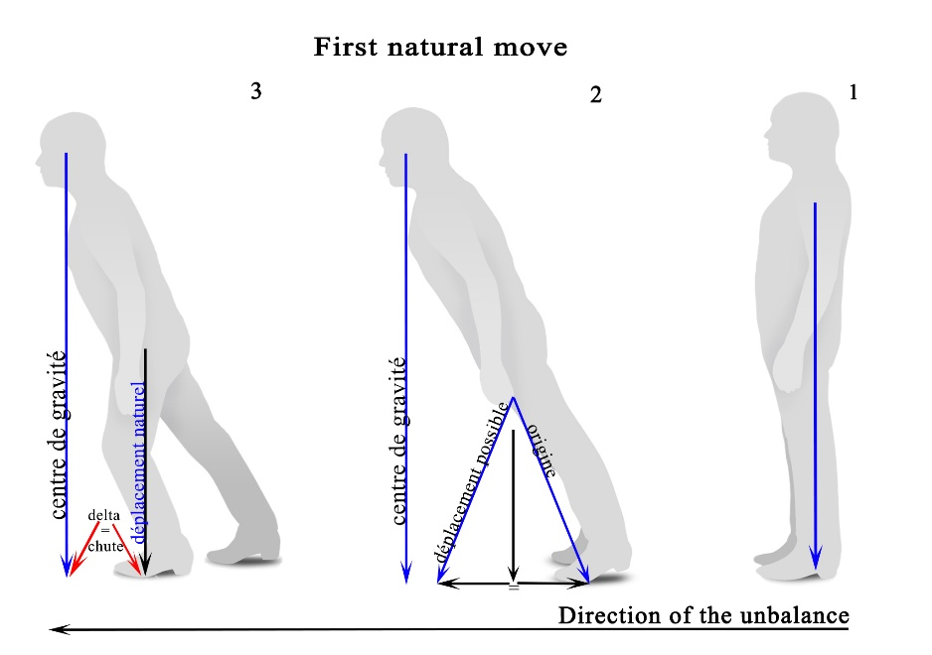
equilibre naturel 1 4665 détouré 1
6a. Progress by front movement (line progression)

Checking - with the help of your partner, recreate the second primitive movement :
The person "A" is on a balance position, supports assembled on the ground, with only the energy required to hold himself in this position, preferably with closed eyes not to be distracted by the outdoor life.

The person "B" will create the movement of the person "A" pelvis by a frontal action forward or backward (sharp but without excessive force) at the level of the pelvis (center of gravity).

One notices that the person "A", in this "provoked" fall, realizes identically the second primary innate displacement.

During your primitive, second movement free and without immediate hanging, that's what you did
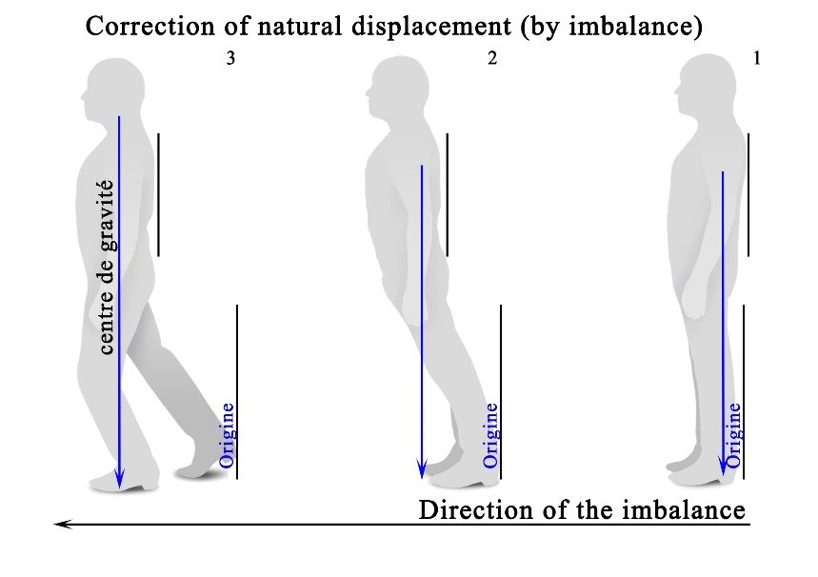
H:\dossier Yves\Le Goff\auto entrepreneur\méthode reprise\Travail Vincent\equilibre_Vincent equilibre naturel corrigé 4673 détouré EN 1

-The fall has been secured by the delay of the upper body (our Center of gravity at the exit of his base of support is ahead of the positioning of the upper body)
-One of our legs, naturally following the law of gravity (mass), received our body to the perpendicularity of its hanging point (hip/pelvis). The point of projection of our Center of gravity is placed approximately in the center of this new support which is the new base of support. The body is stabilized.

This gesture can be renewed, the same causes causing the same effects, it is the other leg released by the previous movement that will recover our balance.

Conclusion: This is an imbalance that will cause our movement, one of our legs alternately ensure our verticality; (Base of my teaching for the understanding of Argentin tango and other activities).

Following its line, the distance between the starting point of the free leg and its point of arrival is identical to the distance traveled by the pelvis (hence the bust). We did a front Frontal.

6b. Progress by sideway deplacements ( change of line)
Repeat this experience with a push of the pelvis to the side, the person "A" is in a position of balance, support assembled on the ground.
Prerequisite: teach your subconscious that during the imbalance the support placed on side movement is the one which must ensure your next balance (right / right leg - left / left leg side). Any other solution is dangerous and uncomfortable (twisted body).
In this "caused" fall, can be seen:
-Naturally the basin "leads" the bust (the movement of the bust is always late) and the free leg.
-Our fall is secured by this delay (our Center of gravity doesn't come out of hits base of support)
-The free leg (displacement side), receives our body to the perpendicularity of its hanging point (hip).

The point of projection of our Center of gravity is placed approximately in the center of this new support. The two supports are on the same side line separated from the value of the movement of the body.
The result and the conclusion are identical to 'front' movement We realized a move side deplacement, "free lateral".
This gesture may be renewed on the other side, the same causes lead to the same effects, but it's the other leg liberated by the previous movement that will retrieve our balance. There is displacement of the body, but no movement of support.
Repeat this experience with a push of the pelvis to the side of the free leg, the person "A" is balanced following a front or rear. The result and conclusion are identical to the 'frontal' move but the two supports meet on the same lateral line, separated from the value of the movement of the body. We realized a sideways "Lateral, free side".

In these two movements, “frontal” or “lateral”, one leg is always free immediately. It is so easy, in the practice of the "Argentine tango" to play in space, and/or play with free assistance from his or her partner, a characteristic of Argentine tango.
In this description of natural walking, our legs must follow our body. We do not need to "do the action" to order them
Other information which is deducted from this market, regardless of the difference in size between the partners, the creator of information will never be able to exceed the possibilities of movement of the receiver of the information. The move of the partners will always be equal.
Imperative for Argentine tango : the support used previously remains in place during the next movement to allow, in dynamic, games in the partner space.

Particularity: There is also the “Lateral” side closed.
(1) which is realized as a result of a lateral position.
o there is a double change of support in the "same time" travel, integrated into our subconscious since our origin.
2) that is realized from a frontal position, a single change of support without changing the orientation of the pelvis.
o This “lateral” cannot be doubled and imposes a next move in front in the direction of the free support.

6c. Change of support (without moving the body compared to the positioning of our center of gravity within our base of support).

With these only two primary functions, front and side, I can't get to my starting position, legs side by side because I say that we must not "order/to initiate" a 'movement' of leg (foot) to get around. The disabled, mechanical leg, have long resolved this difficulty growing on their leg. They realize a 'Vertical' on their leg and Lands on their mechanical leg for the continuity of their displacement.

This movement that I called ' vertical movement " is the supplement to learn and integrate for the practice of the Argentine tango and all the dances in a couple without exception.

Operation in the couple dancing: To reposition the free leg nearly useful leg (leg), to rise with a 'strong' inspiration to grow the bust upwards (without 'take off' the ground support). At the expiration and release will be on this free leg who joined naturally vertically from its point of attachment. It is a move, we'll change so must support (analogy with frontal or lateral displacement).
We will use this technique, in all the dances, to inform our partner for change to support after the return to vertical positioning of the free leg.
7) Terms used to my teaching:

This teaching philosophy requires another vocabulary in comparison with standard teaching.

- The word "foot" is replaced by "ground support" or simply "support". Yes, the foot is the support and vice versa. "But if you keep this language, it will be more difficult to correct your reptilian memory (primary) ", so a slower integration of this other possibility thinking and progress.
-The terms "left & right" are not used, they are confusing. They are replaced by 'Lateral free' or 'Lateral'

The elements of 'choreographic' displacements (drawings on the ground) are defined by:
- Front “Frontal” and back “Frontal” opposite.
-Lateral side free (the positioning of the free leg side) and its complement Lateral side (leg that carries the weight of the body).
-Vertical (upward). (Its opposite > > vertical (downwards) doesn't have the same function).
These five names, complemented by the action of the bust in rotation, associated or not with different intensities of impulses allow to realize all possible moves and all the proposals of the Argentinian tango.

Bust: Upper part of the human body, the belt to the neck. (French: buste)
Trunk: Central part of the human body considered without the head and the members. (French: tronc)
Pelvis: Anatomical term to indicate the basin. Indicate the osseous belt which forms the base of the trunk and is used as junction between the lower extremities, the spinal column and the articulation of the hip. (French: pelvis or bassin)

Nomination of the couple of dance:
- The one who invites, generally a man, is named «creator of movement»
- That who accepts invitation, generally a woman, is named “receiver of movement”

Interest in the practice of the dances in "abrazo".
All dances in a couple are danced in "natural base", on two lines of the ground; aesthetics and comfort. This goal is achievable with our teaching. Imposed by the legs moving, they are usually practiced in four lines of the ground (with the inner lines between thigh).

The Argentine tango dances dislocated position (parallel busts and forming a rectangle in the so-called open position, we 'think' this position following positioning asked our partner in abrazo closed), with the following:
Position dislocated
-four lines of the ground in 'natural base' or 'cross-base' or,
-three lines of the ground in cross-base.
In face to face position
-two lines of movement on the ground in 'natural base' (beginning and resolution of the "salida" or spot and 'game' desired by the "creator of the movement)

8) The 'natural' of the human body operation scheme
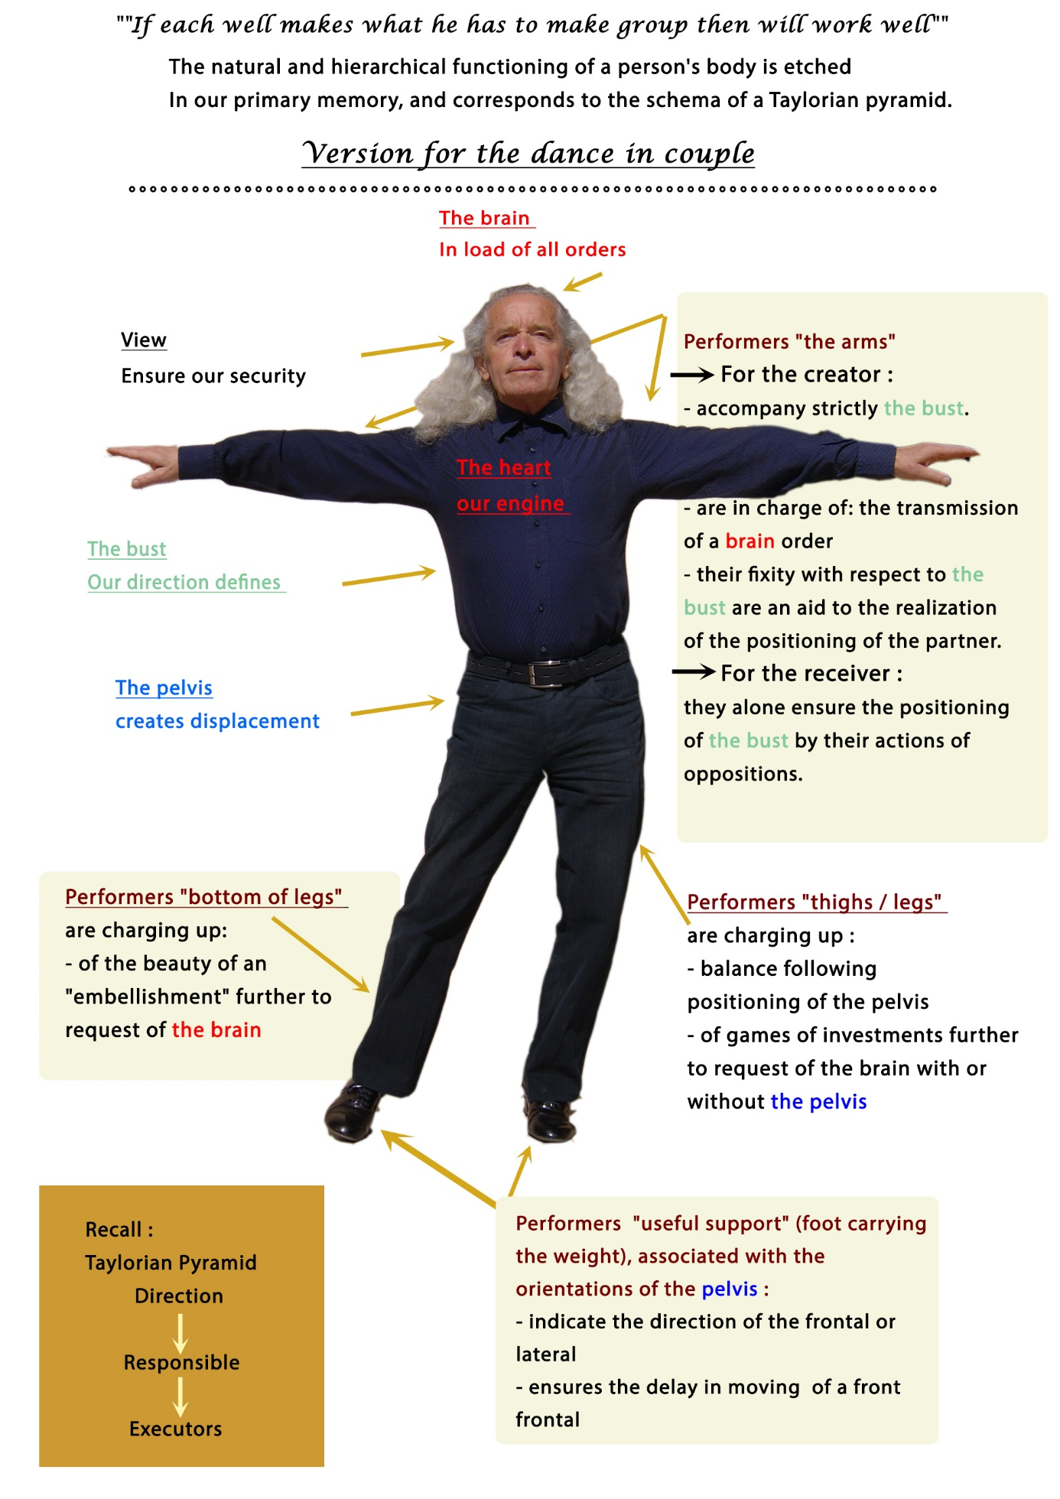
9) The Communication is needed to create the dance couple
This appellation (excerpt "The petit Larousse") has become generic to set several different actions:
- Establish a relationship with others,
- Link and phone call,
- Action to communicate, transmit something to somebody,
- Means and techniques for disseminating messages,
- Promote an activitie,
- Join two things, two places (make them communicate).
are inseparable. They define the functioning of the abrazo (as a couple) dance:
- Establish a relationship with others; ........................................... Listening
- Action to communicate, transmit something to somebody; ...... Proposal

In this pedagogy for the teaching of dances in abrazo with the Argentine tango as support, the " receiver of movement" does not know the future wishes of his partner "creator of the movement". The couple must therefore know the structure of "communication"

Communicating is a key element in creation. It is a priority to feel - together - an action or creation.
Perform an action repeatedly {in the same frame} is communicate? Possible, but not common.

  - You are with other people on the dance floor. There is no communication. (disco dance).
o You dance alone.

  - You are with other people to achieve the same choreography. There is no communication. (Example: line dances).
o You dance alone.

  - You have chosen to share together the movements of the dance. You have communicated on choreography that everyone knows. The communication is then random. (Choreography in couple).
o You are two dancing.

- You are a dance couple. Every moment you are communicating.

The creator of the movement proposes a variation; The receiver of the movement receives (listens) the information proposed and realizes it (communicates); The creator of the movement (listening) and ends the variation by its positioning (communicates).
o It is dance in couple, dance in 'abrazo'.
Your movement on the ground are almost simultaneous (communication delay), and your ground support are always parallel, pedagogy "LEGOFFJOHAN."
…………………………………………………….
In the abrazo (as a couple) dance, the creator will be accurate. All the possibilities of dances are offered only by his bust actions, sometimes combined with the position of his center of gravity, and transmitted by the fixity of his arm in the space of his bust, without haste in the management of his body, "disclosure of information". His gaze exclusively ensures his management of the space with the other dancers.
The “receiver of the movement” focuses his attention only on the receipt of his feelings of changes in the body of the “creator of the movement”. His feelings immediately trigger her reaction, by the action of opposition in his arms to move or put his body in motion "creation of the movement of dance or the proposed move.

10) Transcript of communications applied to the Argentine tango
Roles (creator / receiver) are interchangeable

Creador
begins
movimiento
receiver
responds to
this request
Catcher realizes
this movement
Creator
moves at the
same time
Creator or / and
receiver add
"flourishes".

As a couple: the “receiver of the movement” realizes and highlights the movement
Variants
The “receiver of the movement” can also transmit information of creation.

11) Components to create the couple dancing

Couple dancing, (also called: two, lounge, ballroom... or even defined only by styles: rock, Waltz, salsa, tango...), is composed of three elements with as link a dependent and inseparable hierarchy.
In the order of the harmonization, three elements which constitute dance in couple are:
  - An insubstantial element:
- Music: (rhythms, phrasing,..), can exist alone, it does not define the couple dancing.
  - An element of hardware:
o Only the “creator of the movement”, integrates the musical variations to create movements in space. He forms a pair with the music, this is generally the definition of dance.
    - He creates and proposes the movement, according to his listening, his interpretation and the changes in music, by displacement of his pelvis associated or no to a direction of his bust.
With a fixed positioning of his arm in the space of his bust, he is at the origin of the movement of the couple and will be placed at the end of this movement by the parallel placement of its "supports on the ground ".
The “creator of the movement” knows at every moment the positioning on the ground of the supports of the “receiver of the movement” by listening to the information transmitted by the top of the body of his (her) partner.
  - An element of hardware:
o The “receiver of the movement” - receives (decodes or decrypts). According to sensations (impulses) and directions provided by the bust of the “creator of the movement”, he uses his arm to contact, (support on the arm of the “creator of movement”) to create an action of opposition, assistant to the realization of movements or displacements of all or part its bodies.
O the “receiver of the movement” is constantly looking for "mirror effect" by his rectangle positioning or, (at a minimum), parallel to the "upper body" because of information from the top of the body of his (her) partner.
The “receiver of the movement” expresses the dance and defines the expression "dancing couple».
12) Music: fundamental to the creation of the couple dances.
1. Music: for the dancers, it is the combination
o Rhythm
▪ periodical return of strong times and low times, regular disposal of musical sounds (on the view of intensity and duration), which gives to the piece his speed, his characteristic shape.
o His "musical phrase" which the dance creators have associated a "sentence of dance."
o Instrumentation:
▪ defined by referential instruments

The combination of pace and instrumentation defines a style that will be common and recognizable by the dancers to share a festive moment, with the movements of the body that describe with their supports (feet), the drawings on the floor recommended by the ancients.
The dancer dances. But following his apprenticeship and his level, his relationship with the music will evolve to:
- Dance, accompanying music,
- Dance with music,
- Dance in music, harmony with the musicians, jazz function (creation / improvisation).

The dancers, (which were created at the beginning of the XXth century the majority of currently existing in couple dances), referred to the four criteria that define a musical score:
- The rhythm,
- The construction of the measures,
- The speed of execution,
- The interpretation.

In the same musical family, if one or more of these criteria are changed, the dancers of previous generations have proposed another set of displacements, so another dance...
Conference and workshop given with the complicity of Madam Johan effective, school Creatyv' Tango
Text excerpt of my self-published book: [learn differently "Argentine tango"] currently available.

13) TANGO / a base for general : a walk on the odd time to four-time music.
Two philosophies: argentine or European
It's Argentine immigration that exported the tango in Europe and especially in Paris. On the return of the Argentineans to their country, one can imagine a loss of the Argentinian model, and a transformation of the virtuosity of the Argentineans towards a simpler version, dance and music, which I call "European philosophy”
Argentine tango / musical phrase of sixteen time for tango / musical phrase of eight steps for the waltz / musical phrase of eight time for the milonga. These three musical phrases are associated with a sentence of eight travel dance.
Is the only couple dancing that uses the " natural base (N.B.) " (movement of the side legs), either face to face (rectangle of the four ground support) or dislocated (parallelogram of the four ground support), and the " cross-base (C.B.) " (movement of diagonal legs), mandatory in dislocated on three or for lines of the ground.

i. Main base: N.B. / frontal rear - lateral free side (the Creator move outside the couple: "deport" function)- N.B. or C.B. / two front frontal - « receveur » latéral fermé ; "Receiver" Lateral closed side; creator back in N.B. - front frontal – lateral on free side - vertical.
ii. Secondary base: called 'the tour' (right or left) which represents a merry-go-round (an axis and a circumference).
……………………………………………………..
14) The pedagogy applied to other dances - the travel database
(Drawing on the ground of the creator / receiver communicates in opposition to action and thus is placed in reverse drawing, either in opposition)
a - NB / Viennese Waltz / music of two sentence against three time
i. 1^{era} measure (1/2 turn): frontal before - lateral - vertical
ii. 2th measure (1/2 turn): front back - lateral – vertical

b. Chachacha / musical two phrase measures four-stroke
i. 1^{era} measure: frontal before - frontal back - lateral free side - lateral side closed
ii. 2nd measurement: frontal back - frontal before - lateral free side - lateral side closed

c. Boogie Woogie / musical eight-time phrase
i. ⁽¹⁾ frontal back - ⁽²⁾ frontal before - (^{3 and 4)} vertical and lateral (closed side) - ⁽⁵⁾ frontal back - ⁾ frontal before ⁽⁶⁾ - ^{(7 and 8)} vertical and lateral (closed side).
Note: variant during the change of place "held»:
You will replace : ^{(3 and 4)} vertical and lateral (side) by ^{(3 and 4)} vertical and frontal before (closed side)

d. Rock'n Roll / is derived from the "Boogie", is danced on six times without musical phrase.
i. ⁽¹⁾ frontal back - ⁽²⁾ frontal before - ^{(3 and 4)} vertical and lateral (closed side) - ^{(5 and 6)} vertical and lateral (closed side)
Note: variant during the change of place "held»:
You will replace : ^{(3 and 4)} vertical and lateral (side) by ^{(3 and 4)} vertical and frontal before (closed side)

e. Salsa- previously Mambo / musical eight-time phrase
i. ⁽²⁾ frontal before – ⁽³⁾ frontal back - ⁽⁴⁾ vertical - ⁽⁶⁾ frontal back - ⁽⁷⁾ frontal before - ⁽⁸⁾ vertical
ii. 'Salsa' variants: The "frontal front" shall be replaced by "frontal rear"
- all "fronts" are replaced by "lateral free side"

f Zorba (school) / 5 phrases of eight time
- For times right support - For times left support
- Two times “frontal before – frontal back - frontal back - frontal before”
- Ballad to the left (diagonal frontal movements) ... frontal before - lateral - frontal back - lateral - frontal before - lateral - frontal back - backward maintain Left ankle Left.
- Ballad to the right (diagonal frontal movements) ... frontal before - lateral - frontal back - lateral - frontal before - lateral - frontal back - backward maintain right ankle right.
- Frontal front (two-stroke) / frontal back (two-stroke) / four-sided frontal
g.

We all can move "by walking" from a point to other one. But isn't there, in harmony with nature, a nice way to walk, respectful of our body ?
This article is to me armature following the listening of the emission “Large good makes you” (France Inter/Tuesday, May 20, 2017): “Some benefits of walk”
To re-listen to the programme, follow this link:
https://www.franceinter.fr/emissions/grand-bien-vous-fasse/grand-bien-vous-fasse-02-mai-2017

There is a great concordance with the teaching that I have been building since 2002 in the dance school "CréatYv 'Tango"
Some extracts of the speakers:
- Roger-Pol Droit : We walk by imbalance by starting a small fall, catching up, reproducing ... and start again to advance.
- Jacques-Alain Lachant (http://www.jacqueslachant.com/) : the walk must be light and there must be a special motor for this to happen.
- Christophe André : (walking meditative) ... walking is a miracle and one realizes in full awareness of the moment when one loses the balance and, of course, the other leg alone finds the right way ... it is soothing and fertile for the consciousness of the functioning of our body.
- Julia Zimmerlich : Walking is a gentle physical activity, very complete for the body
  - Strengthening of respiratory and muscular capacity; Fortification of bones ... ; Reduced in the risks of falls… Better oxygenation…
If I do not question the remarks of Mrs Julia Zimmerlich, I think that it misses in this leisure the mobility and the utility of the various components of the trunk (flexibility) and also the knowledge of “to go well” named light walk by Mr Jacques-Alain Lachant to give to the body the beneficial effects that are owed to it. Let us note that in our daily necessities needs that for walk leisure or sporting walk, we move in only one direction: ahead.

Professor “dance couple” using exclusively the “Argentinian tango” (*) my teaching priority is the return towards natural walk, initiated with the second test of “displacement/walk in imbalance” of our life, intégrant utility of the various components of the trunk. Recall, our legs have as a principal function to ensure our balance after each imbalance.
For the practice of dances, which I call "popular" (as a couple, as a couple, folk, in line), dancing is a codified march punctuated by a musical style.
In this step, we move in four directions: front (frontal before), front (back), lateral (right side), lateral (left side), with bust which ensures the direction y pelvis which ensures the imbalance of the displacement chosen. All movements have the same value.
On our balance support, we need to create an upward access (vertical: pelvic elevation completed with an inspiration to continue our elevation). Utility, our leg at rest leaves its point of contact on the ground and returns close to our support of balance naturally.
Advantage of the «walk of dance», use of dissociation, or not, of bust and of the pelvis.
To walk it is to dance, to dance it is to walk, to dance the Argentinian tango (which includes the totality of necessary displacements to dance «popular dances», it is in more:
  - Re-teach or learn to walk (light walk)
  - To go in abrazo
    - In natural base (lateral) on two lines of displacement on the ground
    - In base cross (diagonal) on three or four lines of displacement on the ground
  - To create the communication (proposal, listening, answer, realization, conclusion)
  - To remove all the no useful energies to listen to positioning of the bodies
  - To practise three speeds of walk: slow (tango), merry (canyengue) - average (waltzes) - fast (milonga)
  - To integrate/interpret with the bodies the music suggested (memory action)
  - To prepare festive moment (care of oneself and its behaviour) to share a danced musical travel (user-friendliness)

Walking and the dance are indissociably and are the shortest way towards a perennial wellness y welfare.

